

Software Engineering Department
Braude College of Engineering
Final Project – Phase A (61998)

Dynamic Labyrinths - Asymmetric Hunter vs. Builder

CODE: 26-1-D-22
By:
Elio Pikuli
Elio.Pikuli@e.braude.ac.il
Maxim Lazarenko
Maxim.Lazarenko@e.braude.ac.il

Advisor:
PhD. Sulamy Moshe
MosheSu@braude.ac.il
Link to GitHub:
https://github.com/ElioPikuli/Dynamic-Labyrinths---Asymmetric-Hunter-vs.-Builder.git

Table of Contents
Abstract 2
1. Introduction 3
2. Related Work 4
3. Background 5
3.1. Pathfinding Algorithms 5
3.2. Machine Learning 6
3.3. Unity Engine 6
3.3.1. Multiplayer 7
3.3.2. ML-Agents and training in Unity 7
3.3.3. Reinforcement Learning 7
4. Requirements 8
4.1. Functional 8
4.2. Non-functional 8
5. The Process 9
5.1. Research and Development 9
5.1.1. Constraints and Challenges 9
6. Diagrams 11
6.1. Package Diagram 11
6.2. Activity Diagram 12
7. Verification and Evaluation 13
7.1. Evaluation 13
7.2. Verification 13
8. References 14
9. Appendices 15

Abstract

Dynamic Labyrinths - Asymmetric Hunter vs. Builder is an innovative asymmetric multiplayer game designed to bridge the gap between theoretical computer science and interactive entertainment, with a primary focus on the comparative analysis of pathfinding algorithms.
The game operates within a dynamic 3D environment, utilizing a cross-platform architecture to create distinct roles for players. A PC user takes on the role of a collector, navigating a maze to gather puzzle pieces, while a mobile user acts as a strategist, dynamically altering the map's topology to assist autonomous bots in guarding these objectives. This asymmetry creates a constantly shifting landscape, presenting unique challenges for navigation and obstacle avoidance in real-time.
The core technical contribution of the project lies in its post-round analysis and algorithmic comparison engine. Once a round is completed, the system analyzes the final map layout using a suite of different pathfinding algorithms to calculate the theoretically optimal path. The system then presents the player with the specific algorithm that achieved the best performance for that unique map configuration. This educational feedback loop is further enhanced by a replay mode, where players receive real-time decision-making suggestions based on the calculated optimal route, allowing them to visualize algorithmic efficiency in practice.
Developed using modern game development frameworks to support cross-platform synchronization, the application serves as both a competitive experience and a visualization tool. By gamifying the differences between heuristic and non-heuristic search methods, the project aims to provide an intuitive understanding of how different algorithms adapt to complex, dynamic environments.

Introduction
Dynamic Labyrinths - Asymmetric Hunter vs. Builder is a multiplayer strategy game designed to captivate players while providing a unique, fun, and enjoyable approach to visualizing and learning computer science concepts, particularly in the field of pathfinding algorithms and graph theory.
Traditional methods of learning algorithms can sometimes feel abstract and disconnected from practical implementation, relying heavily on static diagrams and pseudocode. By immersing players in a competitive, asymmetric 3D environment where the map itself is variable, Dynamic Labyrinths brings algorithmic logic to life. Through navigating complex mazes and strategically altering the terrain, players gain hands-on experience with fundamental principles such as shortest-path calculation, obstacle avoidance, and heuristic search efficiency.
In Dynamic Labyrinths, players have the unique opportunity to experience the difference between static and dynamic environments in a tangible way. Instead of just analyzing a graph on paper, one player (the Builder) actively alters the map topology in real-time to assist bots to capture the Hunter, while the other (the Hunter) must navigate these changes.
During gameplay, the Hunter makes quick navigation decisions to avoid bots and collect puzzle pieces. They achieve this by learning from post-game analysis and actively incorporating the advantageous suggestions provided by the system’s optimal route calculation during replay modes, ensuring they take the most efficient steps to navigate the maze successfully.
Dynamic Labyrinths goes beyond traditional hide-and-seek gameplay by integrating a comparative analysis engine. This allows us to offer real-time guidance during replays, showing players exactly how specific algorithms would have solved the maze faster. This seamless integration of competitive gameplay and algorithmic visualization ensures that players not only have fun but also develop and refine their understanding of computational efficiency.
Dynamic Labyrinths caters to computer science students, strategy enthusiasts, and anyone seeking an entertaining and educational gaming experience. Whether you're a software engineering student aiming to reinforce your knowledge of search algorithms or simply a gamer with a passion for logic and strategy, this game is designed to fulfill your need for interactive and captivating learning.
All the mentioned above happens while the Hunter frantically collects puzzle pieces to complete the objective, while the mobile player dynamically changes the 3D map to guide guard bots, creating a tense race against the opponent to determine the superior strategist.

Related Work
Traditional educational methodologies are increasingly scrutinized for relying on passive, "one-size-fits-all" information transfer that often leads to student disengagement. Consequently, pedagogical research has shifted toward interactive, student-centered approaches, with Game-Based Learning (GBL) (Boeker, 2013) emerging as a prominent solution to bridge the gap between abstract content and learner engagement.
Recent empirical evidence supports the superiority of gamified environments over traditional methods. For instance, Boeker et al. (2013) found that medical students using an educational adventure game achieved significantly higher cognitive scores and reported greater engagement than those using conventional scripts. This suggests that embedding content within interactive narratives enhances both knowledge acquisition and learner participation.
These findings are corroborated by Gudadappanavar et al. (2021), whose research in pharmacology education revealed that gamified sessions led to marked improvements in post-test scores compared to standard tutorials. Their study highlighted that GBL (Gudadappanavar, 2021) creates an active, "student-centered" environment that stimulates critical thinking and transforms learning from a passive review into an enthusiastic, problem-solving experience.
Drawing upon these findings, our work proposes a game-based educational tool designed not to replace the existing curriculum, but to serve as a powerful, supplementary enhancement. To demonstrate the practical efficacy of different navigation strategies, our system employs a comparative framework where multiple pathfinding algorithms compete to determine the optimal route on a given map. When a level ends, the system evaluates algorithms such as D Lite* (Koenig, 2002), LPA* (Koenig, 2004), ARA* (Likhachev, 2003), RRT* (Karaman, 2010) and HPA* (Botea, 2004). The algorithm that calculates the optimal path in the shortest time "wins." The winning algorithm is then displayed to the user, accompanied by educational information explaining its specific mechanics and why it outperformed the others in that specific scenario.

Background
This section is dedicated for the description of terms, algorithms and methods used in this book.

Pathfinding Algorithms
Pathfinding (Korf, 1988) is the computational process of determining the most efficient route through a complex environment. By treating a map as a navigable network, algorithms analyze potential journeys and weigh factors such as distance and safety to generate a precise path that avoids obstacles. This logic is fundamental to both digital and physical systems; it powers intelligent character movement in video games and drives critical real-world technologies like GPS, logistics networks, and autonomous robotics, enabling machines to navigate spaces effectively without human guidance.
In our project, we implement and compare five algorithms, each chosen to demonstrate a specific strategy for solving these navigation problems:
- LPA*: Designed for dynamic environments, Lifelong Planning A* (LPA*) is a search method engineered for systems that must "adapt their plans continuously to changes of the world or their models of the world" (Koenig et al., 2004, p. 94). It addresses "path-planning problems on known finite graphs whose edge costs increase or decrease over time" (Koenig et al., 2004, p. 95), a common scenario in robotics and navigation. In these situations, simply adhering to an initial path is often insufficient because "the original plan might no longer apply or might no longer be good" (Koenig et al., 2004, p. 94), necessitating a method that can handle frequent updates without the delay of starting over.
To address this efficiency challenge, LPA* operates as an "incremental version of A*" (Koenig et al., 2004, p. 94). Rather than treating every change as a new problem to be solved from the beginning, the algorithm "reuses information from previous searches" (Koenig et al., 2004, p. 94) to adjust the existing plan. This capability allows it to "find shortest paths for series of similar path-planning problems potentially faster than is possible by solving each path-planning problem from scratch" (Koenig et al., 2004, p. 94). While its initial search is identical to a standard A* search, its "subsequent searches are potentially faster because it reuses those parts of the previous search tree that are identical to the new one" (Koenig et al., 2004, p. 93).
The algorithm's speed comes from its ability to selectively target repairs. Instead of recalculating the entire map, LPA* "updates only a subset of those start distances that are incorrect" (Koenig et al., 2004, p. 99), leaving unaffected areas alone. Analytical results highlight the algorithm's "potential advantage... if the path-planning problems change only slightly and the changes are close to the goal" (Koenig et al., 2004, p. 93). By combining the heuristic focus of A* with efficient incremental updates, LPA* serves as a powerful tool for real-time replanning in large, changing domains.
- D* Lite: Designed for robot navigation in unknown terrain, where a robot must move toward a goal while discovering new obstacles or traversing costs. Unlike standard search methods that plan a complete path once, D* Lite is built to handle scenarios where "the robot could use conventional graph-search methods when replanning its paths after discovering previously unknown obstacles," but doing so would be inefficient. Instead, it uses incremental search to speed up replanning by "orders of magnitudes" over repeated A* searches.
The algorithm "searches incrementally from the goal back to the start", reversing the direction used in LPA*. This inversion is critical for efficient replanning because the robot's current position (the start) changes as it moves, while the goal typically remains static. By rooting the search tree at the goal, the algorithm can reuse the existing search tree even as the robot moves to new nodes. As edge costs change (e.g., an obstacle is discovered), D* Lite updates only the affected parts of the graph, ensuring that "most of the changed goal distances are irrelevant for recalculating a shortest path" and can be ignored.
This design allows a robot or agent to "rapidly replan its route as it discovers new information." D* Lite uses a heuristic to focus its search and "reuse information from previous searches". When the robot detects a change in the environment (like a blocked path), D* Lite updates the cost estimates (g-values) only for the relevant inconsistent nodes and re-expands them to find a new optimal path. This capability allows it to adapt quickly, avoiding the "substantial idle times" associated with replanning from scratch
- ARA*: Designed for real-world planning problems where "time for deliberation is often limited" (Likhachev et al., 2003, p. 1). It functions as an anytime heuristic search algorithm that "tunes its performance bound based on available search time" (Likhachev et al., 2003, p. 1). This capability allows it to balance the need for a fast initial response with the desire for an optimal solution, making it suitable for complex tasks like robotic arm manipulation or outdoor rover navigation.
The algorithm operates by executing a series of A* searches with "inflated heuristics" (Likhachev et al., 2003, p. 1). It "starts by finding a suboptimal solution quickly using a loose bound" (Likhachev et al., 2003, p. 1), specifically by using a large inflation factor ϵ. As time allows, ARA* "tightens the bound progressively" (Likhachev et al., 2003, p. 1) by decreasing ϵ. This iterative process ensures that "after each search a solution is guaranteed to be within a factor ϵ of optimal" (Likhachev et al., 2003, p. 2), eventually converging to a provably optimal solution if sufficient time is provided.
A key innovation of ARA* is that it "reuses search efforts from previous search efforts" (Likhachev et al., 2003, p. 1) rather than starting from scratch for each improvement. By maintaining a list of "locally inconsistent" states—those whose costs have changed but haven't been propagated—ARA* avoids "re-computing the state values that have been correctly computed in the previous iterations" (Likhachev et al., 2003, p. 2). This reuse makes ARA* "significantly more efficient than other anytime search methods" (Likhachev et al., 2003, p. 1), achieving substantial speedups in experiments with high-dimensional robotic planning.
- RRT*: Is an incremental sampling-based algorithm designed for complex motion planning problems. It is particularly effective in high-dimensional spaces because it avoids the "excessive computational burden" of explicitly constructing obstacles, which complete planning algorithms require (Karaman & Frazzoli, 2011, p. 2). Instead, it relies on a collision-checking module and random sampling to build a graph of feasible trajectories, allowing it to handle systems with many degrees of freedom where determining the exact free space is computationally infeasible.
While the standard RRT algorithm is probabilistically complete (it finds a solution if one exists), it is not asymptotically optimal; analytical results show that "the cost of the solution returned by broadly used sampling-based algorithms [like RRT] converges almost surely to a non-optimal value" (Karaman & Frazzoli, 2011, p. 1). In contrast, RRT* provides a rigorous guarantee of asymptotic optimality. This means that as the number of samples increases to infinity, the cost of the path returned by RRT* "converges almost surely to the optimum" (Karaman & Frazzoli, 2011, p. 1), ensuring the robot eventually finds the most efficient route possible.
The key innovation that enables this optimality is the "rewiring" of the tree structure. Unlike RRT, which simply connects a new sample to the nearest node, RRT* performs local optimization steps:
  - Best Parent Selection: When adding a new sample (), the algorithm searches its neighborhood for the parent node that yields the minimum accumulated cost to , rather than just the geometrically closest node (Karaman & Frazzoli, 2011, p. 15).
  - Restructuring: After adding , the algorithm checks if this new node offers a cheaper path to any of its existing neighbors. If reaching a neighbor via is more efficient than its current parent, the algorithm "rewires" the tree by updating that neighbor's parent to (Karaman & Frazzoli, 2011, p. 15). This continuous refinement minimizes redundancy and straightens paths over time.
- HPA*: Designed to overcome the performance bottlenecks of standard A* when applied to large, complex environments. To do this, it employs abstraction to create a simplified representation of the search space. Instead of treating the map as a massive collection of individual grid cells, HPA* "abstracts a map into linked local clusters" (Botea et al., 2004, p. 1). This hierarchical structure allows the algorithm to reason about the map at a higher level, significantly reducing the problem complexity.
The method "divides the grid into local clusters" (Botea et al., 2004, p. 1), typically rectangular blocks of size n×n. For each cluster, HPA* identifies "entrances" (points where travel is possible between adjacent clusters) and pre-calculates the optimal paths between them. "At the local level, the optimal distances for crossing each cluster are pre-computed and cached" (Botea et al., 2004, p. 1). These pre-computed paths and entrances form a high-level graph where nodes represent the entrances and edges represent the cost to traverse between them.
Planning in HPA* is a two-step process. First, the algorithm "plans a route on this abstract level" (Botea et al., 2004, p. 1), finding a path across the high-level graph. This step is very fast because the high-level graph is much smaller than the original grid. Once the abstract route is determined, HPA* "refines it into a detailed path" (Botea et al., 2004, p. 1). This refinement is often done on demand or segment-by-segment, meaning the agent can start moving immediately without waiting for the full low-level path to be computed.
By decomposing the problem, HPA* achieves "significantly reducing memory usage and computation time" (Botea et al., 2004, p. 1). Experimental results show that HPA* can be "up to 10 times faster" than highly optimized A* (Botea et al., 2004, p. 1) while producing paths that are "within 1% of optimal" (Botea et al., 2004, p. 1). This makes it ideal for real-time applications like commercial games where memory and CPU resources are constrained.

Machine Learning
Machine learning (El Naqa , 2015) is a subset of AI that shifts the computing paradigm from explicit programming to pattern recognition. Instead of following strict, pre-coded rules, algorithms analyze vast datasets to identify patterns, building adaptive models that learn from experience much like humans do. This allows systems to generalize and make decisions about new, unseen data without constant human intervention. Its applications are vast, powering digital tools like recommendation engines and natural language processing, as well as physical innovations like self-driving cars and medical diagnostics. Ultimately, machine learning enables computers to solve complex problems where traditional manual coding is insufficient.

Unity Engine
Unity is a premier cross-platform game engine that serves as a comprehensive development ecosystem for creating interactive 2D and 3D content. At its core, it acts as a technological foundation that abstracts away the complex, low-level mathematics required for rendering graphics, simulating physics, and handling user input.
Unity features we aim to use:
- Comprehensive C# Scripting Environment Unity utilizes C# as its primary programming language, providing a type-safe and object-oriented environment ideal for implementing complex logic.
- Graphics and Visualization Tools The engine’s rendering pipeline offers powerful tools for visualizing abstract data.
- Performance Profiling and Analysis Unity includes a built-in Profiler that monitors the consumption of system resources in real-time.
- Cross-Platform Deployment One of Unity’s defining strengths is its ability to deploy a single project to multiple operating systems with minimal code modification.
- Advanced UI System (Canvas) Unity provides a robust User Interface (UI) system known as the Canvas, which allows for the creation of intricate overlays and interactive elements.

Multiplayer
Unity facilitates seamless cross-platform connectivity between PC and mobile devices through its native networking stack, Netcode for GameObjects (NGO), combined with the Unity Relay service. Rather than requiring developers to build complex socket infrastructure or manage low-level IP configurations, this system abstracts the networking layer, allowing a PC to act as a "Host" and a mobile device to connect as a "Client" using a secure, cloud-based middleman.

ML-Agents and training in Unity
Unity ML-Agents is an open-source toolkit that extends the Unity game engine, enabling it to function as a rich simulation environment for Artificial Intelligence (AI). While Unity is traditionally used for game development, ML-Agents allows developers and researchers to use its physics and rendering capabilities to create complex training scenarios. This transformation enables the training of intelligent agents for various applications, including controlling Non-Player Character (NPC) behavior, automated testing of game builds, and robotics simulations, without requiring extensive background knowledge in machine learning.
The training process is facilitated by a communication bridge that connects the Unity environment (written in C#) with an external training process (written in Python).
- Unity Side (C#): Contains the "Learning Environment," which includes the agents, sensors, and the environment itself. It is responsible for collecting observations and executing actions.
- Python Side: Contains the "Python Trainers" (typically using libraries like PyTorch), which run the actual machine learning algorithms (like PPO or SAC) to update the agent's "brain" or policy based on the data received from Unity.
- The Communicator: An external communicator links these two sides, allowing them to exchange data in real-time during the training loop.

During training, the agent operates in a continuous cycle:
- Collect Observations: The agent gathers data about its current state using sensors. This can include numerical data or visual data.
- Policy Decision: These observations are sent to the Python trainer (or the internal neural network during inference), which uses a policy to decide the best course of action.
- Take Action: The agent executes the chosen action in the Unity environment.
- Receive Reward: The environment provides a reward signal based on the outcome of the action, which is used to update the policy for future decisions.
This cycle repeats thousands or millions of times until the agent's policy converges to an optimal behavior.

Reinforcement Learning
Reinforcement Learning (RL) (Ding, 2020) within the Unity ecosystem is primarily facilitated by the ML-Agents Toolkit, which effectively converts the game engine into a high-fidelity simulation environment for training artificial intelligence. In this framework, the Unity scene functions as the "Environment," while the character or entity being trained acts as the “Agent”.

Requirements

Functional
- The system will visually render the step-by-step execution of the optimal pathfinding algorithm.
- The system will support cross-platform multiplayer sessions connecting PC hosts and mobile clients.
- The system will generate a Machine Learning agent to compete against the player.
- The system will display educational information regarding the logic of the current optimal algorithm (for the specific map).
- The system will allow the mobile player to add obstacles in real-time.
- The system will allow Replayability of the map.
- The system will show the optimal algorithm time to finish the map.

Non-functional
- The game will be deployable and fully functional on both Windows and Android operating systems.
- The game will automatically adapt the user interface layout to different screen resolutions and aspect ratios.
- The game will guarantee mathematically accurate results for all implemented pathfinding algorithms.
- The game will synchronize multiplayer game states.
- The game will abstract input handling to ensure consistent behavior across mouse and touchscreen devices.
- The game will be fun.
- The game will achive its educational purpose.

The Process

Research and Development
Our research and development process began with a foundational online course on Unity development, recommended by our project advisor, which provided us with the essential skills for navigating the engine's interface and mastering C# scripting. As we transitioned into the development of our Proof of Concept (POC) our methodology shifted towards an iterative, "learn-by-doing" approach.
We integrated Deep Reinforcement Learning (DRL) for bots training. This required setting up a complex development environment, including managing specific Python dependencies and configuring a dedicated environment to facilitate communication between the Unity "Body" and the Python "Brain”.
For the agent's logic, we designed a Proximal Policy Optimization (PPO) training loop. The training logic relies on a strictly defined reward system. The agent receives a high positive reward (+2.0) for capturing the target and a minor negative penalty for colliding with obstacles, encouraging efficient navigation through our procedurally generated mazes. We faced significant implementation challenges, such as synchronizing the Vector Observation space and debugging infinite loops during the random spawning phase. By leveraging official Unity documentation, technical forums, and tools like TensorBoard to visualize training metrics, we successfully optimized the training process.
To engineer a Hunter capable of escaping the maze efficiently while evading guard Bots, we implemented advanced incremental heuristic search algorithms, such as LPA*, ARA* and D* Lite.
Unlike standard A*, which must recalculate a path from scratch every time an enemy blocks the way, D Lite* and LPA* allow the Hunter to dynamically "repair" its path in real-time.

Constraints and Challenges
As we progress, we anticipate encountering several significant constraints and challenges, particularly regarding optimization, implementation, and computational limitations. A primary concern is optimization for mobile hardware, running complex pathfinding calculations while simultaneously rendering real-time visualizations is computationally expensive, requiring us to strictly manage memory allocation to prevent battery drain and frame-rate drops on Android devices.
From an implementation perspective, synchronizing the mathematical execution of the algorithms with Unity’s visual system presents a complex logical challenge we must ensure the visualization accurately reflects the step-by-step search process without freezing the main application thread.
Furthermore, ensuring seamless cross-platform compatibility introduces challenges in both networking, specifically synchronizing game states between PC and mobile via the Unity Relay to minimize latency, and user interface design, as the controls must be intuitive and responsive across vastly different screen sizes and input methods (mouse vs. touch).
Finally, the integration of ML-Agents involves the difficulty of training a neural network that is intelligent enough to navigate dynamic maps effectively while remaining computationally light enough to run locally on a mobile device.

Diagrams

Package Diagram
- Core.Algorithms -> Core.GridSystem
(The Algorithms need access to the Nodes to calculate costs.)
- Systems.Networking -> Core.GridSystem
(The Network needs to sync the Grid state between players.)
- UI.Visualization -> Core.GridSystem
(The UI needs to read the Grid to know where to draw walls.)
- Systems.AI -> Core.GridSystem
(The AI needs to "observe" the Grid to decide where to move.)
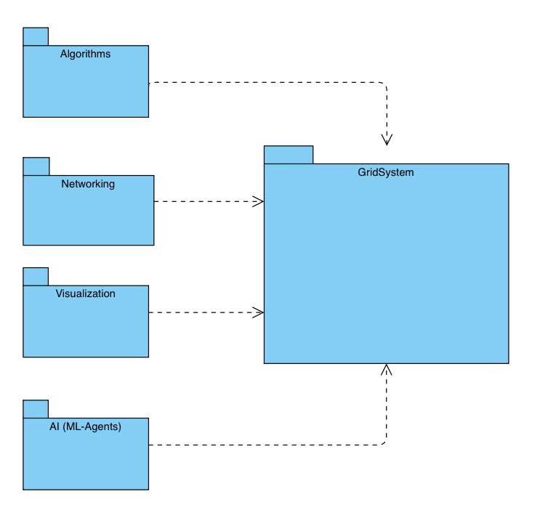

Activity Diagram
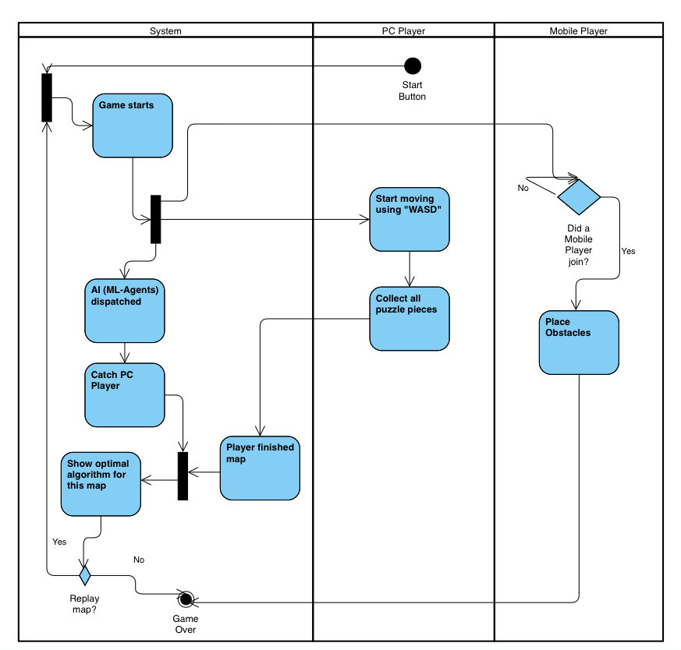

Verification and Evaluation

Evaluation
To ensure the system meets its functional requirements and achieves its educational objectives, we will employ a testing strategy divided into four key categories. Each category utilizes quantifiable measures to verify the project's success.

Algorithmic Integrity & Mechanics Evaluation This phase verifies the core computational logic of the system. We must ensure that the "gameplay", which in our case is the simulation of pathfinding, is mathematically accurate and responsive.

System Performance & Network Evaluation Since the project relies on cross-platform multiplayer, we must evaluate the technical stability of the connection between distinct hardware types.

ML-Agent Proficiency Evaluation This evaluation focuses on the intelligence and behavior of the Reinforcement Learning agent.

User Experience & Educational Evaluation Finally, we will assess the design's effectiveness in delivering educational concepts.

Verification
To technically verify that our software meets the defined requirements, we will utilize the Unity Test Framework (UTF). This industry-standard tool allows us to write automated tests that run directly within the Unity Editor and on target devices, ensuring our code behaves exactly as expected.
We will aim to use three specific tools within this framework:

EditMode Tests (Unit Testing for Algorithms) These tests run instantly in the Unity Editor without needing to "play" the game. We will use them to verify Algorithmic Integrity.

PlayMode Tests (Integration Testing) These tests run the game loop in real-time, allowing us to verify Game Mechanics and Interaction.

Performance Testing Extension (Benchmarking) We will install the Unity Performance Testing package, which integrates with UTF to measure execution time and memory usage.

References
- Boeker, M., Andel, P., Vach, W., & Frankenschmidt, A. (2013). Game-based e-learning is more effective than a conventional instructional method: A randomized controlled trial with third-year medical students.
- Botea, A., Müller, M., & Schaeffer, J. (2004). Near optimal hierarchical path-finding.
- Ding, Z., Huang, Y., Yuan, H., & Dong, H. (2020). Introduction to reinforcement learning. In Deep Reinforcement Learning: Fundamentals, Research and Applications.
- El Naqa, I., & Murphy, M. J. (2015). What is machine learning? In Machine Learning in Radiation Oncology.
- Gudadappanavar, A. M., Benni, J. M., & Javali, S. B. (2021). Effectiveness of the game-based learning over traditional teaching-learning strategy to instruct pharmacology for Phase II medical students.
- Karaman, S., & Frazzoli, E. (2010). Incremental sampling-based algorithms for optimal motion planning. Robotics: Science and Systems.
- Koenig, S., & Likhachev, M. (2002). D* Lite. Proceedings of the AAAI Conference on Artificial Intelligence.
- Koenig, S., Likhachev, M., & Furcy, D. (2004). Lifelong Planning A*. Artificial Intelligence.
- Korf, R. E. (1988). Optimal path-finding algorithms. In L. Kanal et al. (Eds.), Search in Artificial Intelligence.
- Likhachev, M., Gordon, G. J., & Thrun, S. (2003). ARA*: Anytime A* with provable bounds on sub-optimality. Advances in Neural Information Processing Systems.

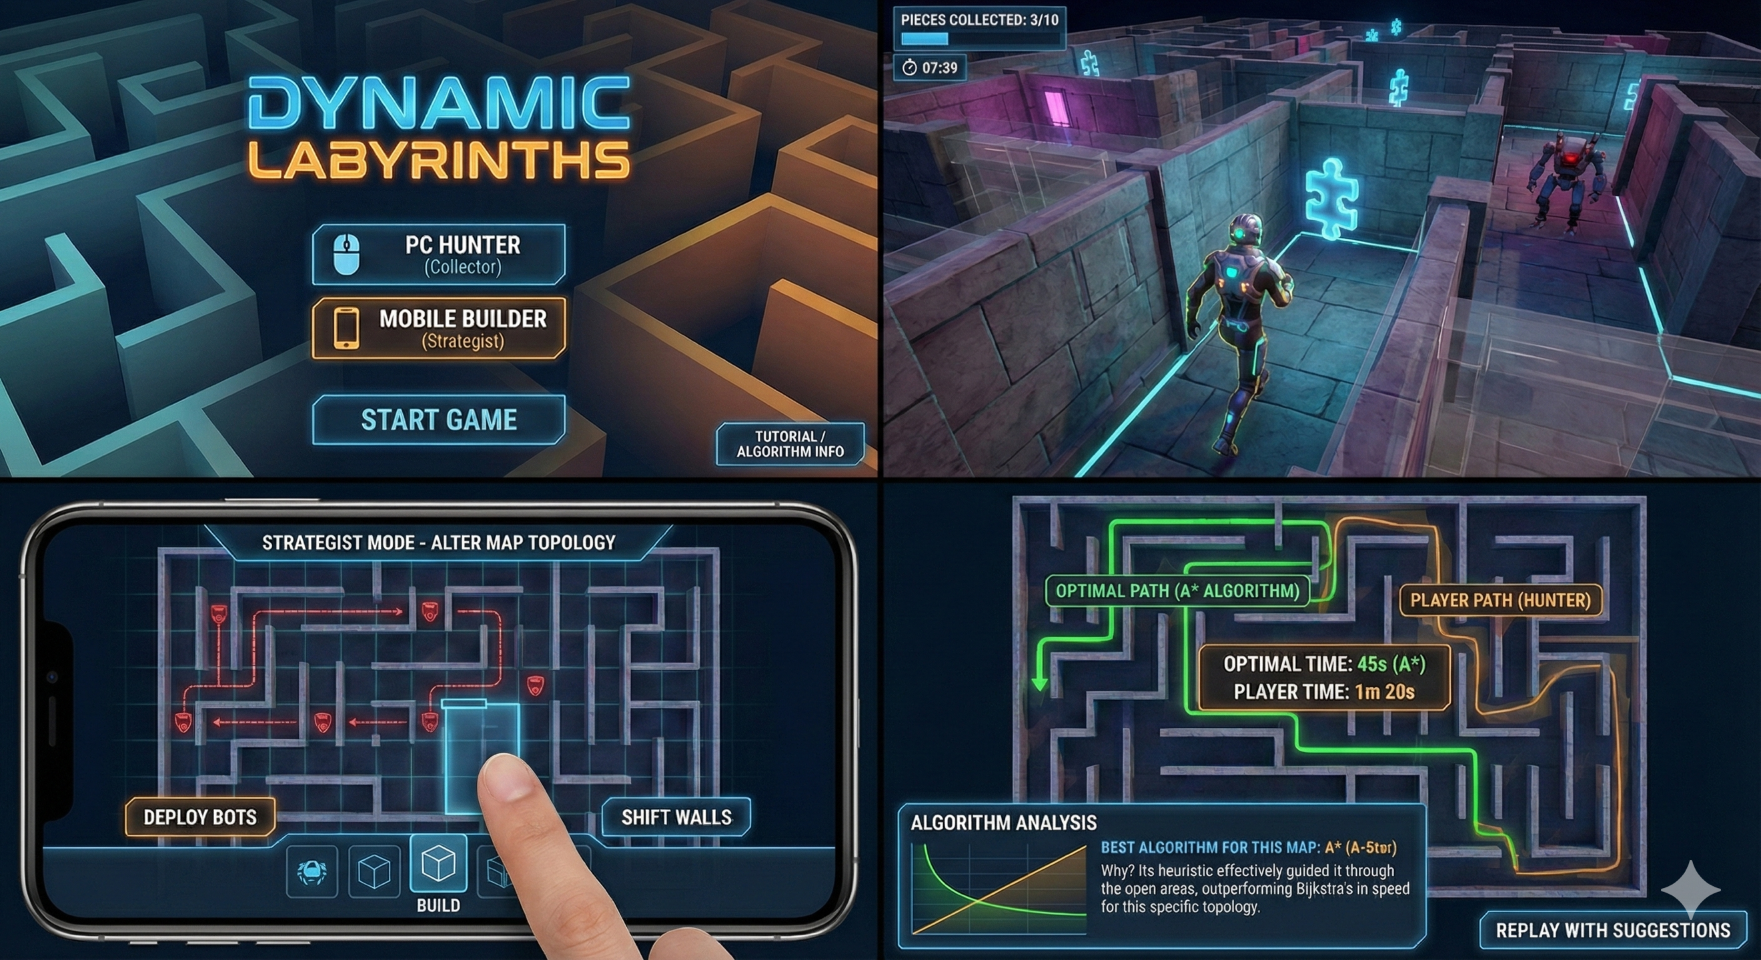
Appendices



